

U Mobile - MVNO
Core Network
Technical Specifications Document
- U Mobile S8HR Charging Specifications

Change Tracker
No | Date | Description | Change by
V0.1 | 28 October 2025 | 1st draft | Vincent Tan

CONTENTS

1. Purpose 3
2. Overview 3
3. Charging specification 4
3.1 CAMEL Voice charging for S8HR 4
3.2 SMS charging for S8HR 5

Purpose

This document outlines the specifications MVNO needs to follow in their SCP/OCS to be able to charge voice and SMS for S8HR scenario.

Overview

In CS voice and SMS roaming architecture, the traffic is handled in the Visited network. Settlement for MVNO is from TAP, whatever the usage used by voice and SMS in the visited network, it is charged back to MVNO following the contract rate. For data roaming, it is similar, it is charged back to MVNO from TAP.

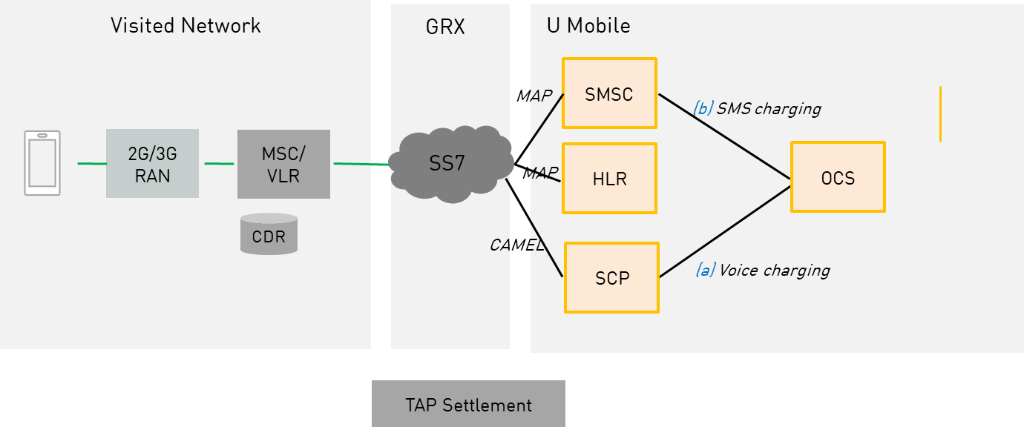

As networks progressively shut down 2G/3G, the new architecture for voice and SMS is via S8HR where voice and sms is handled in the home network IMS. S8HR will be the predominant roaming method in most networks.

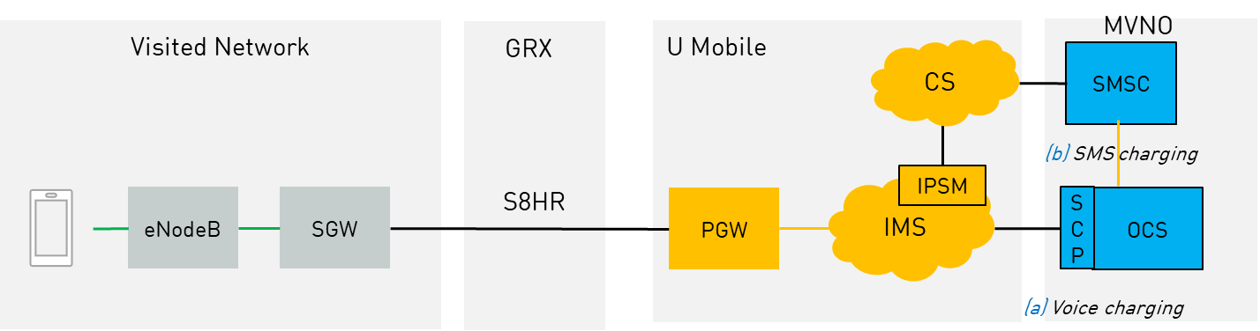

Charging specification

CAMEL Voice charging for S8HR

During S8HR, the CAMEL IDP will have two fields to indicate the S8HR:

• VLR number which can be used by MVNO BSS to map to the roaming voice rate table
• Location Information which can be used by bill presentation to indicate the roaming country.(optional if MVNO uses VLR info for the bill presentation)

S8HR roaming voice is identified when VLR Number is not equal to 60xx.
The format of the VLR
• VLR = CC0000000MCCMNC
e.g.
- Sample for 2 digits of MNC, MCC=525 MNC=05 (Starhub, Singapore), VLR=65000000052505 (len=14)
- Sample for 3 digits of MNC, MCC=310 MNC=410 (Guam, USA), VLR=100000000310410 (len=15)

For the Location information field, the CGI is automatically added from the Cell information provided by the Roaming Partner network. In event this information is not provided by Roaming Partner network, the default VLR Number and Cell id will be provided in the IDP.

Country | PVNI | Mapping VLR Number  (configurable) and carried in IDP message | Location Information in IDP (CGI)  ZTE will truncate eCGI to fit into CGI
Singapore | S8HR.ims.mnc05.mcc525.3gppnetwork.org | e.g. 65000000052505 | SG eCGI-> CGI
USA | S8HR.ims.mnc410.mcc310.3gppnetwork.org | e.g. 100000000310410 | USA eCGI-> CGI
Other RP  (configured country name) | S8HR.ims.mncXX.mccXXX.3gppnetwork.org | New VLR number to be assigned  Change according to RP | Change according to RP
Default  (use generic “Roaming” in bill presentation) | S8HR.ims.mnc.mcc.3gppnetwork.org | 65000000000000 | 0010100000000
Example of PVNI /VLR number/CellID of S8HR

In case of missing Mobile Country Code (MCC) from network, network will use default VLR (value and remarks as per table below), MVNO BSS should have a default S8HR roaming rate to charge the subscriber.

Roaming Partner | Mapping VLR | Remarks
Dummy | 65000000000000 | Dummy VoLTE VLR - location Info unavailable. MVNO needs to charge a default Tariff

SMS charging for S8HR

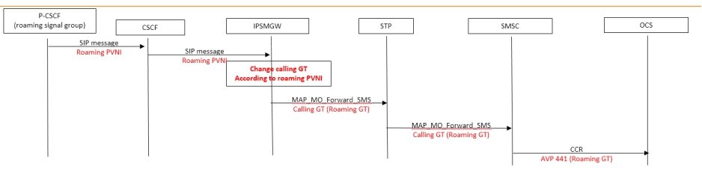

For S8HR SMS-MO charging, MVNO BSS needs to recognize the following GT in MAP MO Forward SMS MSC field. Only two possible rates are possible to be configured in MNVO BSS for S8HR SMS-MO charging– Singapre and rest of the world.

P-CSCF PVNI for OB SMS | IMS node (IPSMWG) | GT in MSC field in OCS charging in SMSC to OCS | OB VoLTE Zone for SMS charging
s8hr.mnc(abc).mcc(ABC).3gppnetwork.org  abc: mnc for all Singapore partner,e.g.05  ABC=MCC for for all Singapore partnere.g.525 | IVSSHXA | 60181000888 | All RP in Singapore
s8hr.mnc(xxx).mcc(XXX).3gppnetwork.org  xxx: mnc for all other partner except Singapore  XXX=MCC for for all other RP | IVSSHXA | 60181000355 | Rest of RPs
s8hr.mnc(abc).mcc(ABC).3gppnetwork.org  abc: mnc for all Singapore partner,e.g.05  ABC=MCC for for all Singapore partner,e.g.525 | IVSSKPA | 60181000777 | All RP in Singapore
s8hr.mnc(xxx).mcc(XXX).3gppnetwork.org  xxx: mnc for all other partner except Singapore  XXX=MCC for for all other RP | IVSSKPA | 60181000356 | Rest of RPs
 | Home VoLTE SMS (info)
All Local SBC PVNI | IVSSHXA | 60181000031 | Home SMS MO
All Local SBC PVNI | IVSSHKPA | 60181000366 | Home SMS MO

S8HR settlement

Rates will be following the current MVNO charging principal for roaming voice.

